Chapter 4, Solution 10.

Using Fig. 4.78, design a problem to help other students better understand superposition. Note, the letter k is a gain you can specify to make the problem easier to solve but must not be zero.

Although there are many ways to work this problem, this is an example based on the same kind of problem asked in the third edition.

Problem

For the circuit in Fig. 4.78, find the terminal voltage V_{ab} using superposition.

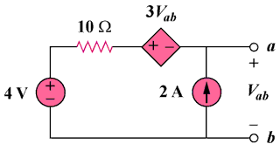
Figure 4.78
For Prob. 4.10.

Solution

Let v_{ab} = v_{ab1} + v_{ab2} where v_{ab1} and v_{ab2} are due to the 4-V and the 2-A sources respectively.

(a)
3v_{ab1}
+ −
+
v_{ab1}
−
4V

+
−
10 Ω
(b)
2 A
3v_{ab2}
+ −
10 Ω
+
v_{ab2}
−

For v_{ab1}, consider Fig. (a). Applying KVL gives,

- v_{ab1} – 3 v_{ab1} + 10x0 + 4 = 0, which leads to v_{ab1} = 1 V

For v_{ab2}, consider Fig. (b). Applying KVL gives,

–v_{ab2} – 3v_{ab2} + 10x2 = 0, which leads to v_{ab2} = 5

v_{ab} = 1 + 5 = 6 V

